***SCREENSHOT***

**SOURCE CODE:**

package apache;

import org.apache.commons.io.FileUtils;

import java.io.File;

import java.io.IOException;

import org.openqa.selenium.OutputType;

import org.openqa.selenium.TakesScreenshot;

import org.openqa.selenium.WebDriver;

import org.openqa.selenium.chrome.ChromeDriver;

import org.openqa.selenium.chrome.ChromeOptions;

public class screenshot {

public static void main(String[] args) throws IOException {

// TODO Auto-generated method stub

System.setProperty("webdriver.chrome.driver", "C:/Users/adhis/Downloads/Compressed/chromedriver-win64/chromedriver-win64/chromedriver.exe");

ChromeOptions options = new ChromeOptions();

options.addArguments("--remote-allow-origins=*");

//creating obj for web driver

WebDriver driver=new ChromeDriver(options);

driver.get("https://www.swiggy.com/");

driver.manage().window().maximize();

//creating reference is the first step

TakesScreenshot ss=(TakesScreenshot)driver;

//taking screenshot and storing it in the temporary file

File source=ss.getScreenshotAs(OutputType.FILE);

//creating destination file

File des=new File("C:/Users/adhis/OneDrive/Pictures/Screenshots/swiggy.png");

//moving the file from source to destination

FileUtils.copyFile(source, des);

}

}

**OUTPUT:**

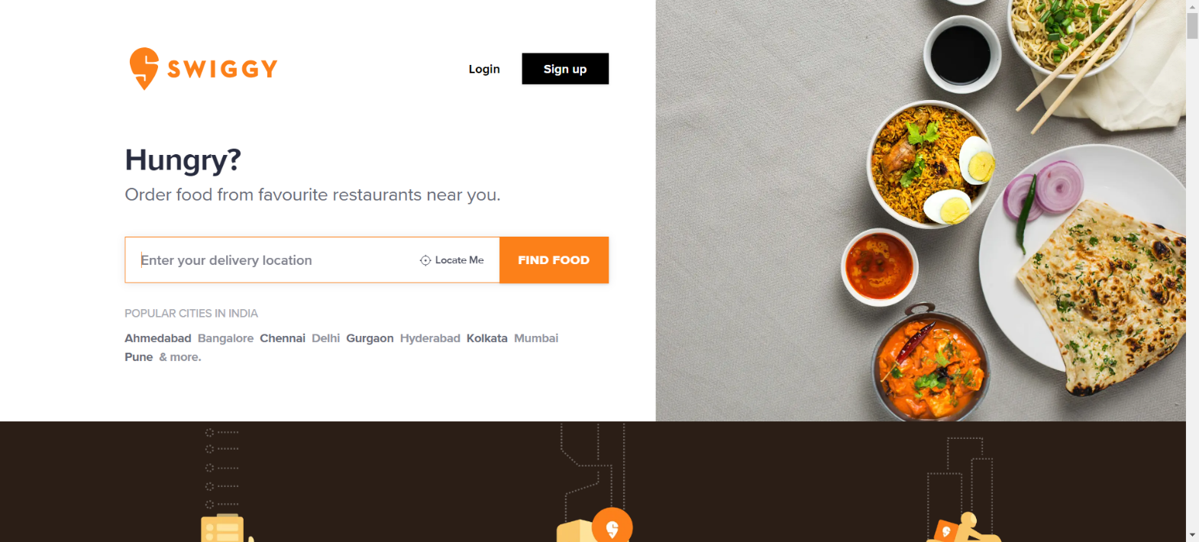This is the picture taken by code and saved in given path